CodeBlocks is already installed in the lab. The instructor will explain how to set up a project in, how to write code, compile, build, execute, etc.

* If you are doing this by yourself, make sure you follow the directions in the file *__notes_installing_CodeBlocks*, available in Canvas.

The instructor will also explain what and how to submit the lab report. All submissions are electronic, in Canvas!

The purpose of this lab is just to get used to typing C code exactly – do not worry if you do not understand all the parts of each program!

[0] Warmup: What is the error in this code? Which line?

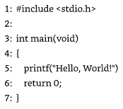 Answer: ______________________________________________

[1] Enter the following program, compile it, and execute it:

#include <stdio.h>

int main() {

printf( "Hello, world!" );

printf( "C programming\n" );

printf( "at Tarleton\n" );

return 0;

}

Explain in your own words what the program does (did you notice the newline characters \n?):

_______________________________________________________________________________

_______________________________________________________________________________

_______________________________________________________________________________

[2] Solve Exercise 2 at the end of Lesson 1:

Enter the following program, compile it, and execute it:

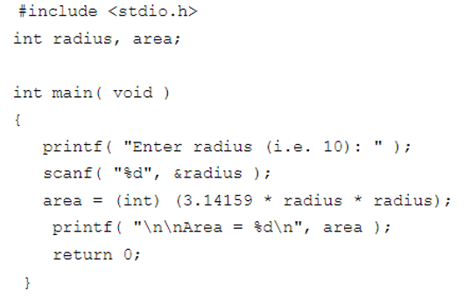

Explain in your own words what the program does:

_______________________________________________________________________________

_______________________________________________________________________________

_______________________________________________________________________________

Answer the questions:

* What lines contain statements? ________________________
* What lines contain variable definitions? ________________________
* What lines contain comments? ________________________
* On what lines are functions called? ________________________

[3] Solve Exercise 3 at the end of Lesson 1:

Enter the following program, compile it, and execute it:

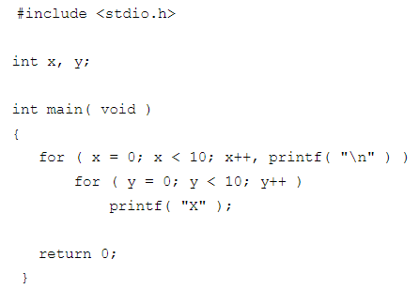

Explain in your own words what the program does:

_______________________________________________________________________________

_______________________________________________________________________________

_______________________________________________________________________________

[4] Count in decimal, binary and hex from 0 to 33 (side-by-side):

|  |  |  |  |  |  |  |  |  |  |
| --- | --- | --- | --- | --- | --- | --- | --- | --- | --- |
| Dec | 0 | 1 | 2 | 3 | 4 |  |  |  | 8 |
| Bin | 0 | 1 | 10 | 11 | 100 |  |  |  | 1000 |
| Hex | 0 | 1 | 2 | 3 | 4 |  |  |  | 8 |

|  |  |  |  |  |  |  |  |  |  |
| --- | --- | --- | --- | --- | --- | --- | --- | --- | --- |
|  | 10 |  |  |  |  | 15 | 16 | 17 |  |
|  | A |  |  |  |  | F | 10 | 11 |  |
|  | 1010 |  |  |  |  | 1111 | 10000 | 10001 |  |

|  |  |  |  |  |  |  |  |  |  |
| --- | --- | --- | --- | --- | --- | --- | --- | --- | --- |
|  |  |  |  |  |  |  |  |  |  |
|  |  |  |  |  |  |  |  |  |  |
|  |  |  |  |  |  |  |  |  |  |

|  |  |  |  |  |  |  |  |  |  |
| --- | --- | --- | --- | --- | --- | --- | --- | --- | --- |
|  |  |  | 32 | 33 |  |  |  |  |  |
|  |  |  | 20 | 21 |  |  |  |  |  |
|  |  |  | 100000 | 100001 |  |  |  |  |  |

**To submit for lab report**

[1] Solve Exercise 2 at the end of Lesson 2:

Enter the following program, compile it, and execute it

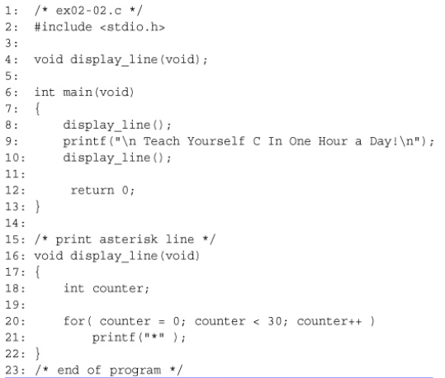

* Attach screenshots of source code and output

Explain in your own words what the program does:

_______________________________________________________________________________

_______________________________________________________________________________

_______________________________________________________________________________

Answer the questions:

* What lines contain statements? ________________________
* What lines contain variable definitions? ________________________
* What lines contain function prototypes? _______________________
* What lines contain function definitions? ________________________
* What lines contain comments? ________________________
* On what lines are functions called? ________________________